Rebecca Heather Wilcox Gwynne CAMTC # 76405
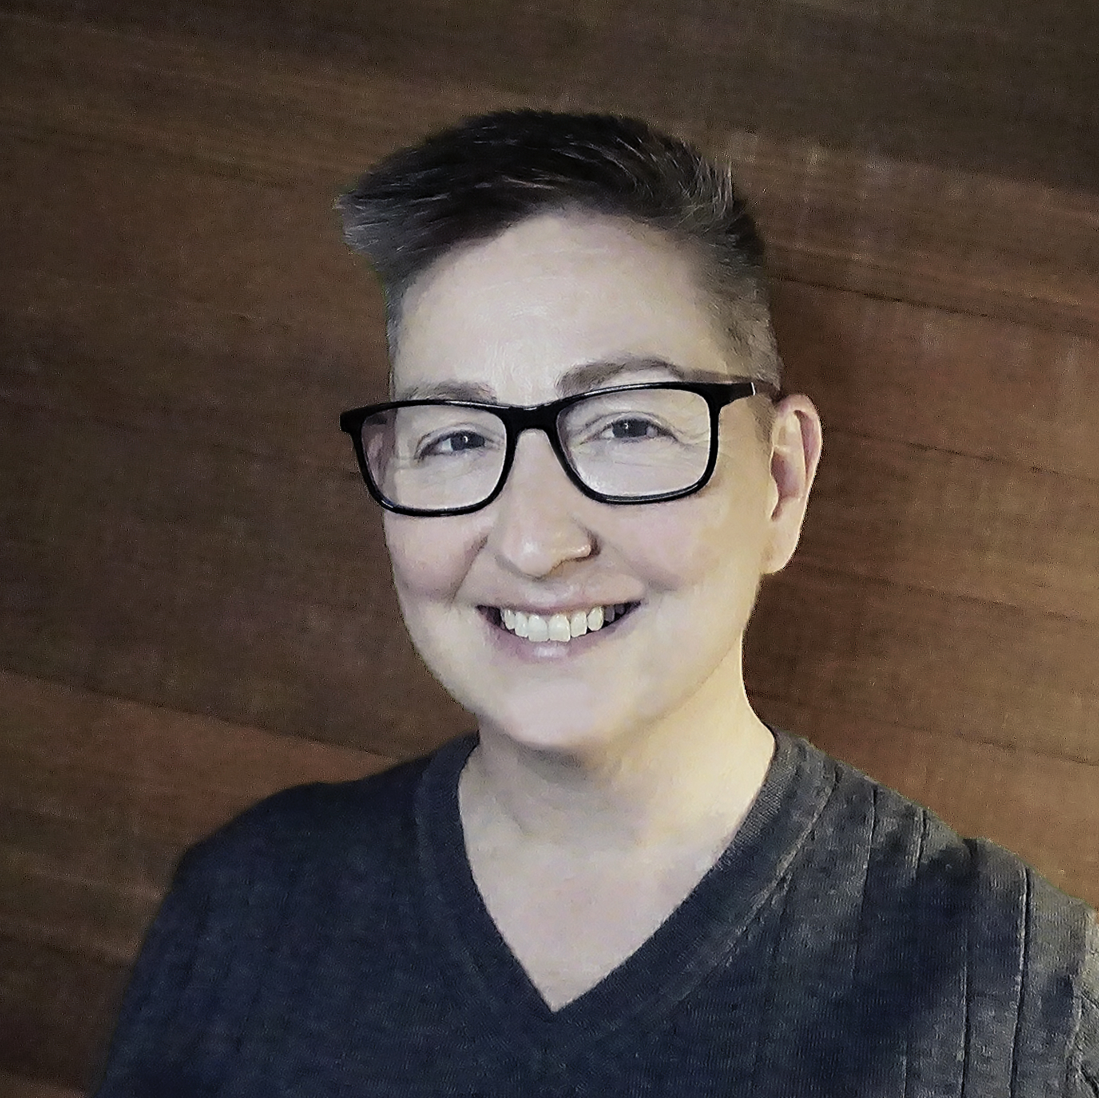 | Los Angeles, CA 90027  E-mail: civilcampaign@gmail.com  Phone: +1 310-774-1483
Participatory Leader and Health Facilitator
Engaged participant championing projects with proven program management and facilitation skills. A strong understanding of leadership principles and their application. Values integrity, service, and stewardship in action to guide projects with diligence and care.
Work Experience

1996 – Current  Holistic Practitioner | Massage Therapist, Health Educator, Life Coach and Reiki Healer practicing independently.
2018 – Current  Co-founder, Program Lead & Fire Tender | Building capacity in the changemaker global community through events and networking initiatives. Enkindle Global. International
2016 – 2018  Group facilitator and Consultant | Contributed to prototype facilitation projects based on Agile values, led small group projects, and created bespoke workshops for organizations. gungus AB. Stockholm, Sweden
2012 – 2016  Owner of We the People | Owner and manager of We the People: Gwynne Spa and Wellness Studio, Led cooperative business model for therapist team. Designed effective client care strategies. Principle holistic therapist and life coach. Wrote Elemental Living as personal coaching platform. Bromma, Sweden
1999 – Current  Presenter Independent | Independent workshop and presentation development for delivery on self-development subjects. International
2013 – 2014 Account Manager for Strategy Insights | Acquired and managed international client accounts for the company. Facilitated meetings between legal counsel and general counsels of large multinationals. Stockholm, Sweden
2011 (Jan – Aug)  Account Manager for Marcus Evans | Developed sales plans, managed international client accounts and taught training classes for multicultural sales teams. Selected for a one month special training at the London office. Stockholm, Sweden
2004 – 2007  Instructor/Mentor National Holistic Institute College of Massage Therapy | Classes taught included theory; anatomy, physiology, and pathology; massage techniques; powerful presentations, and business. Additional duties included mentoring students and acting as assistant manager of the student clinic. Emeryville, CA
2003 – 2004  Writer, Presenter and Marketing Sohnen-Moe Associates, Inc | Developed teaching materials for massage and healthcare professionals for Business Mastery, The Ethics of Touch and newsletter; wrote copy and articles for Sohnen-Moe Associates, Inc.; contributed to The Ethics of Touch by Ben Benjamin and Cherie Sohnen-Moe, Published 2003; presented workshops; and assisted marketing ventures. Tucson, AZ
2001 – 2003 Program Director and Instructor  Apollo College | Program development and implementation of AASc Degree in Massage Therapy. Created multi-dimensional curricula for adult learners in a hands-on and didactic environment. Duties included personnel management; student counselling; creation and implementation of the externship program; assisting graduate job placement; and interfacing with the community. Tucson, AZ
1991 – 1993  Director of Youth Ministries Manito UMC | Maintained a vibrant activity program and personal development for the community aged 12-17. Spokane, WA

Education
2016 – 2017 Digital Art and Graphic Design
Completed 10-month Digital Art Certificate course for graphic design. Loyola Marymount University with Sessions College.

2016 – 2017 Strategic Leadership towards Sustainability Masters of Science
Completed 10-month transformational Masters programme in Karlskrona, Sweden at Blekinge Institute of Technology. Developed knowledge, skills, and global networks to build strategic leadership capacity for co-creating thriving, sustainable societies. Trained as a strategic change agent in our complex world primarily through collaboration. Intending to transform the ways we think, plan, make, act and lead, in order to ‘co-create’ a vibrant, sustainable future.

2007 – 2009 Somatic Psychotherapy Masters Program CIIS
Completed two years of a three-year marriage and family therapist program at the California Institute for Integral Studies. San Francisco, CA. With the primary course work completed and approval to begin practicum I took my leave to move to Sweden.

1996 – 1997 Professional Massage Therapist and Heath Educator NHI
Certificate from the National Holistic Institute College of Massage Therapy. Emeryville, CA. Coursework included Swedish and Shiatsu massage; anatomy, physiology, kinesiology and pathology; clinic logistics; spa therapies; assessment strategies; stress management; powerful presentations; and practice management in a multi-dimensional learning environment.

1986 – 1990 Bachelor of Arts Whitworth College
Bachelor of Arts in Arts Administration with an emphasis in performing arts. Spokane, WA.
Certificates and Professional Associations
CAMTC #76405  Dipl massageterapeut | Certified with the California Massage Therapy Council from August 8, 2018.  Av Branschrådet Svensk Massage certifierad, Stockholm, Sweden, 2010.
Certified Instructor | Bureau for Private Postsecondary and Vocational Education in Therapeutic Massage, Health and Physical Education, State of California, 2007.
National Certification  USA | National Certification Board for Therapeutic Massage and Bodywork, United States of America, 2003.
Massage Therapist and Body Treatment Technician | Gadabout Salons and Day Spas, Tucson, AZ, 1999-2000. Extensive training in spa culture, scrubs, wraps, hot stone, aromatherapy and team building.
Reiki Master/Instructor | Reiki I (1992), Reiki II (1998), Reiki III (1999), CA.
Professional Member | American Massage Therapy Association, 1996-2002.
Professional Member | International Massage Association, 2002-2004.
Certified Personal Trainer | 24Hour Fitness, CA, 1996.
Community Projects
Facilitation  Consultant | Exponential Climate Action For Cities (X-CAC) – International workshop for cities following Global Carbon Law. Kista, Sweden, 2018.  Sustainability Hackathon sponsored by Sweco AB, 2017-11-17.
Project manager and lecturer | RFSU (Riksförbundet för sexuell upplysning) Stockholm – Guest lecturer at Karolinska Institute, project leader, evaluation design, written copy contributions, administration, event coordination, and committee member, Stockholm, Sweden, Spring 2010 – Current
Assistant director, choreographer, actor | Community theater production of Man of La Mancha for Saint Francis in the Foothills UMC, Tucson, AZ, 2003.
Coach | Lavaland Vaulters, Bend, OR, 1994-1996.
Dance | See dance resume. 1988-1996.
Museum intern | Smithsonian, Washington DC 1988. Contributed to the welfare of the Interns and Fellows and promoted the chamber music concerts at the American History Museum.
Museum intern | Museum of Native American Cultures, Spokane, WA, 1990. Developed and implemented the puppet program as project coordinator and script writer.

