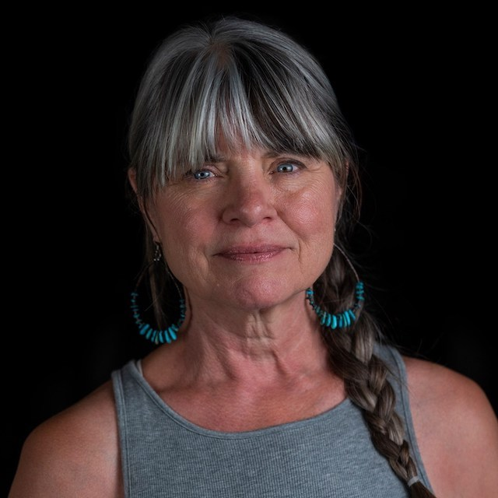

Suzanne Stebila is a LifeForce Energy Healing® Practitioner, Yoga Teacher in Hatha and Kundalini Yoga and BreathWork facilitator. Living in Arizona for 45years she has currently set up residence in Sedona, Arizona. She has been working on her personal growth through connection with the land and the ancestors of the Southwest.

While raising her two children Suzanne attended night school in pursuit of an Art degree all while running a business during the day. Creating art was how she opened the door to seeing life with soft eyes. Leaving her position as business owner and CEO she gave up the office to explore how to help and guide others on their path through meditation, breath (pranayama) and energy healing. Suzanne has a unique way of “seeing” and unwinding bands of energy that constrict and no longer serve the path forward, opening your personal field of Light, self acceptance and self love.

As a LifeForce Energy Healing® Practitioner, certified by the Deborah King Center, Suzanne can assist you in opening to your authentic self and remembering who you were meant to be.

