VISIT US AT OUR SOULSEARCH BOOTH SATURDAY/SUNDAY…
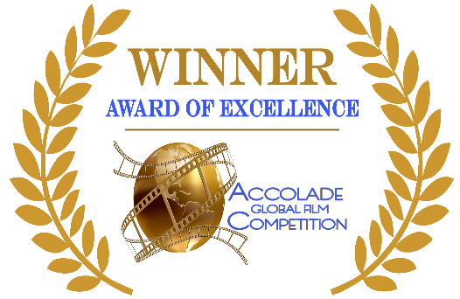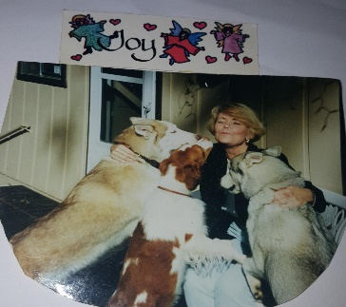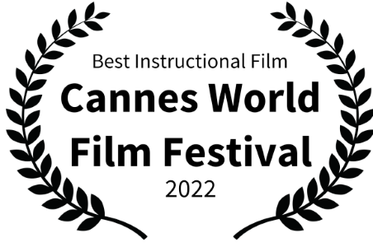

Book & Film: A Storybook for Adults and Other Children: for mental health professionals, teachers and families. A Cannes World Film Festival Winner: Best instructional film. An award-winning animated video (USB computer friendly) plus fully illustrated book. Nine metaphors are teaching tools for social issues such as self-esteem, commitment, fear, mindfulness, competition, purpose, power of thoughts, identity, and friendship. Questions-group activities for clinicians, families, students and children to grow in higher consciousness
Book: One with the Light – A Mystic’s Journey to the Light. This book is the integration of scientific, spiritual and social concepts. In this book, there are many questions and answers: What is the Unconscious Transmission? Has your external teacher found you today? As you think, so you are, reflect CBT counseling techniques.
Book: I BELIEVE IN ANGELS – A journey of a woman’s climb toward Mt. Everest in the Himalayas. Throughout the climb, the reader will learn about many mystical moments and the lessons worth learning for women who are climbing their mountains.
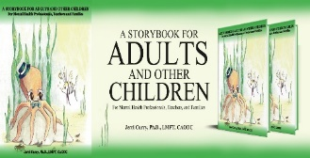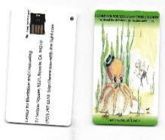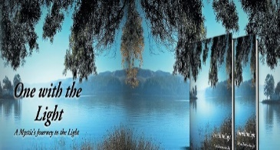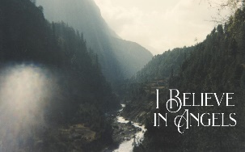
CENTER FOR MEDIATION & COUNSELING (707) 297-0550 77 Solano Square #321, Benicia, CA 94510
https://www.One-with-the-Light.com and https://www.jerricurry.com
*50% discount during SoulSearch event in San Rafael

